Me llamo___________________________________ Tarea __________

**El vocabulario para Unidad _2_. _2_ (parte 1)**

**Los cognados: _____________**

**_____________**

**_____________**

**PALABRA:**

____________________

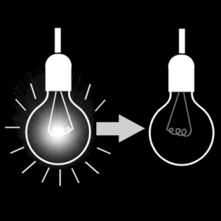

verb adjective noun

**PALABRA:**

____________________

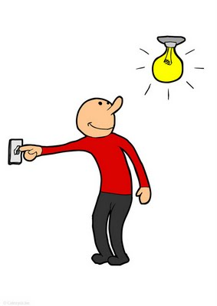

verb adjective noun

**PALABRA:**

____________________

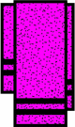

verb adjective noun

**PALABRA:**

____________________

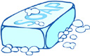

verb adjective noun

**PALABRA:**

____________________

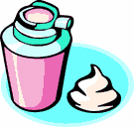

verb adjective noun

**PALABRA:**

____________________

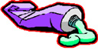

verb adjective noun

**PALABRA:**

____________________

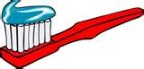

verb adjective noun

**PALABRA:**

____________________

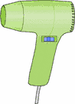

verb adjective noun

**PALABRA:**

____________________

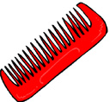

verb adjective noun

**PALABRA:**

____________________

verb adjective noun

**[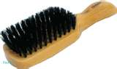](http://www.bing.com/images/search?q=clip+art+hairbrush)**

**El vocabulario para Unidad _2_. _2_ (parte 2)**

**PALABRA:**

____________________

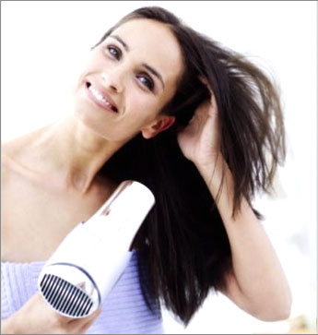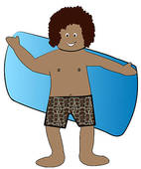

verb adjective noun

**PALABRA:**

____________________

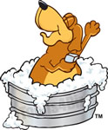

verb adjective noun

**PALABRA:**

____________________

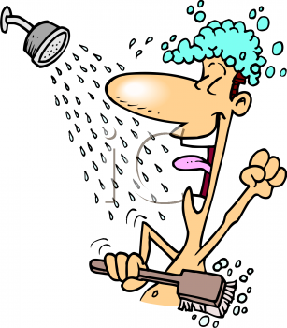

verb adjective noun

**PALABRA:**

____________________

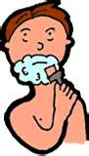

verb adjective noun

**PALABRA:**

____________________

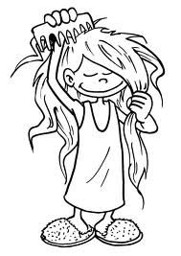

verb adjective noun

**PALABRA:**

____________________

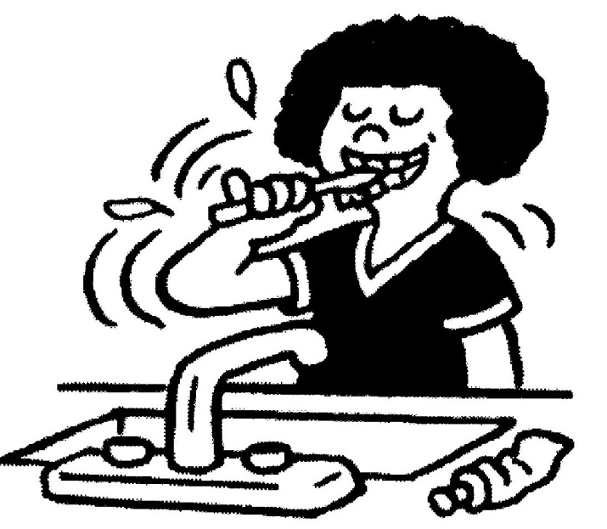

verb adjective noun

**PALABRA:**

____________________

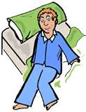

verb adjective noun

**PALABRA:**

____________________



verb adjective noun

**PALABRA:**

____________________

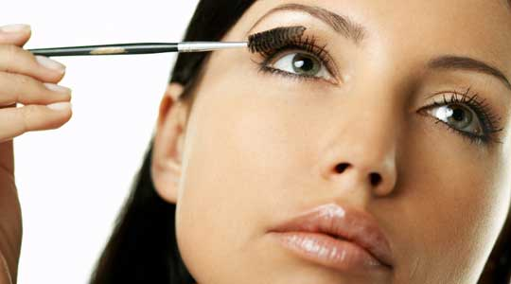

verb adjective noun

**PALABRA:**

____________________

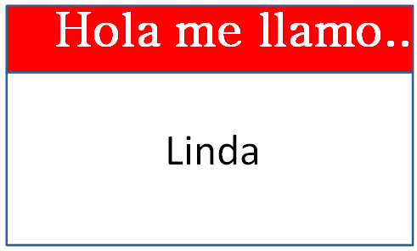

verb adjective noun

**PALABRA:**

____________________

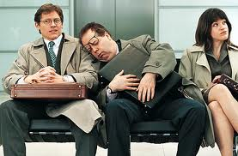

verb adjective noun

**PALABRA:**

____________________

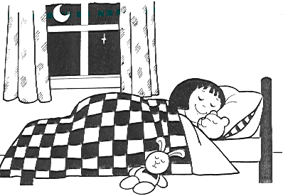

verb adjective noun

**PALABRA:**

____________________

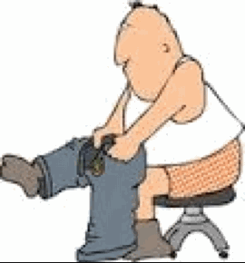

verb adjective noun

**PALABRA:**

____________________

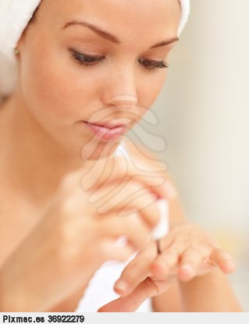

verb adjective noun

**PALABRA:**

____________________

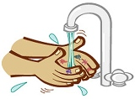

verb adjective noun

**PALABRA:**

____________________

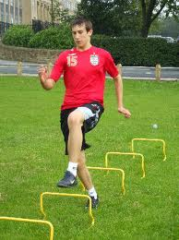

verb adjective noun