Me llamo___________________________________ Tarea __________

**El vocabulario para Unidad _2_. _1_**

**Los cognados – (look like English AND have the same meaning)**

1. _____________________ 5. _____________________ 9. _____________________

2. _____________________ 6. _____________________ 10. _____________________

3. _____________________ 7. _____________________ 11. _____________________

4. _____________________ 8. _____________________

**Usa**  **página 109 en el libro para encontrar el español.**

12. It’s good 12.______________________________

13. Come on! 13. ______________________________

14. Ugh! 14. ______________________________

15. The Tour de France 15. ______________________________

16. The Olympic Games 16. _______________________________

17. The World Cup 17. _______________________________

18. The Panamerican Games 18. _______________________________

19. to win 19. _______ganar____________________

20. to lose 20. _______perder (ie)________________

**PALABRA:**

____________________

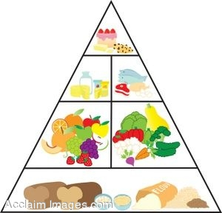

verb adjective noun

**PALABRA:**

____________________

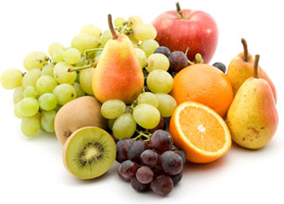

verb adjective noun

**PALABRA:**

____________________



verb adjective noun

**PALABRA:**

____________________

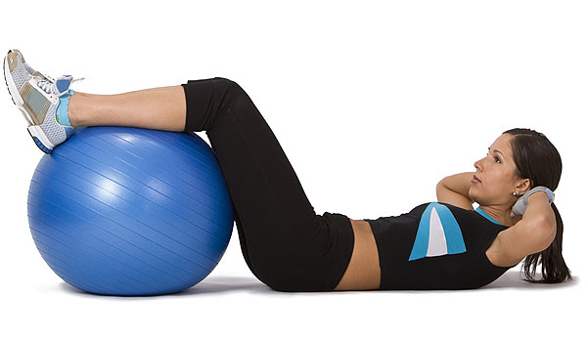

verb adjective noun

**PALABRA:**

____________________

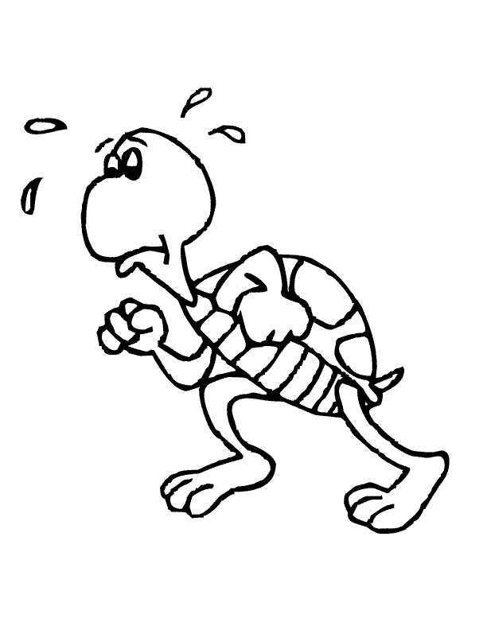

verb adjective noun

**PALABRA:**

____________________

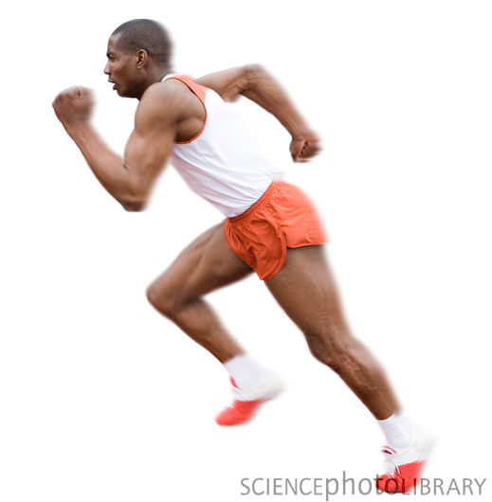

verb adjective noun

**PALABRA:**

____________________

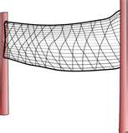

verb adjective noun

**PALABRA:**

____________________

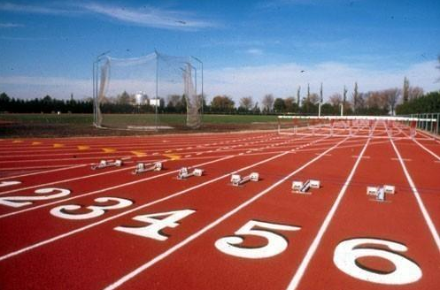

verb adjective noun

**PALABRA:**

____________________



verb adjective noun

**PALABRA:**

____________________

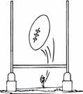

verb adjective noun

**PALABRA:**

____________________

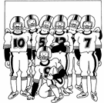

verb adjective noun

**PALABRA:**

____________________

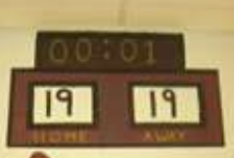

verb adjective noun

**PALABRA:**

____________________

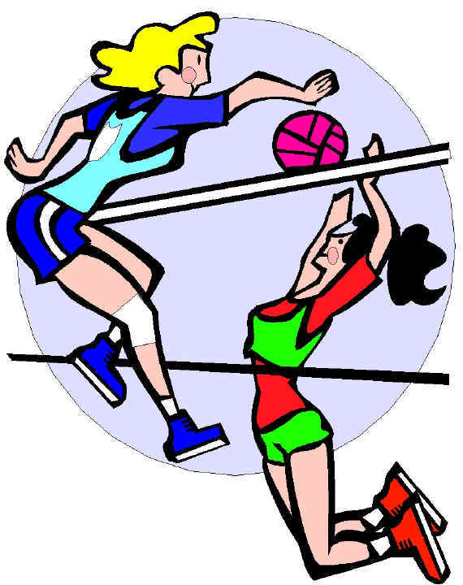

verb adjective noun

**PALABRA:**

____________________

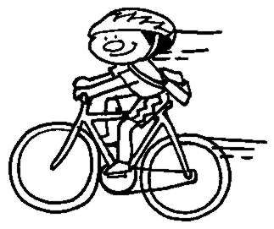

verb adjective noun

**PALABRA:**

____________________



verb adjective noun