Me llamo___________________________________ Tarea __________

**El vocabulario para Unidad _1_. _2_**

**Los cognados – (look like English AND have the same meaning)**

1. _____________________ 5. _____________________ 9. _____________________

2. _____________________ 6. _____________________ 10. _____________________

3. _____________________ 7. _____________________ 11. _____________________

4. _____________________ 8. _____________________

**Usa**  **página 79 en el libro para encontrar el español.**

12. to be on vacation 12.______________________________

13. to send post cards 13. ______________________________

14. to see 14. ______________________________

15. lodging 15. ______________________________

16. to make / have a reservation 16. _______________________________

17. handicrafts 17. _______________________________

18. jewelry 18. _______________________________

19. credit card 19. _______________________________

20. open air 20. _______________________________

21. How…! 21. _______________________________

22. I would like… 22. _______________________________

23. Could I see/ look at…? 23. _______________________________

24. I’ll give… to you for… 24. _______________________________

25. too, too much 25. _______________________________

26. to pay 26. ________pagar___________________

27. price 27. _______el precio__________________

**PALABRA:**

____________________

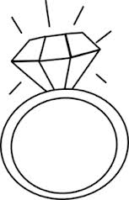

verb adjective noun

**PALABRA:**

____________________

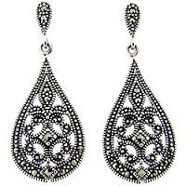

verb adjective noun

**PALABRA:**

____________________



verb adjective noun

**PALABRA:**

____________________

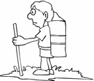

verb adjective noun

**PALABRA:**

____________________



verb adjective noun

**PALABRA:**

____________________

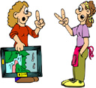

verb adjective noun

**PALABRA:**

____________________



verb adjective noun

**PALABRA:**

____________________

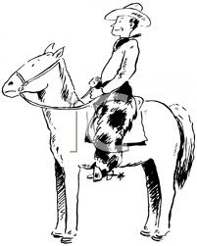

verb adjective noun

**PALABRA:**

____________________

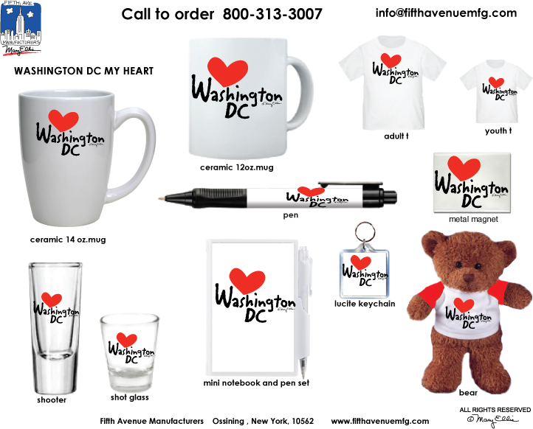

verb adjective noun

**PALABRA:**

____________________

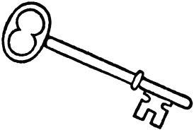

verb adjective noun

**PALABRA:**

____________________

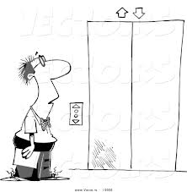

verb adjective noun

**PALABRA:**

____________________

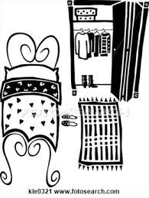

verb adjective noun

**PALABRA:**

____________________

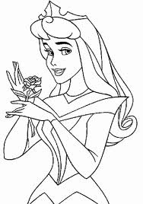

verb adjective noun

**PALABRA:**

____________________

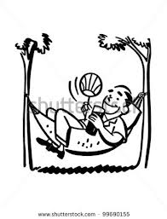

verb adjective noun

**PALABRA:**

____________________

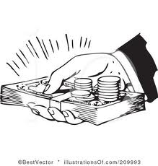

verb adjective noun

**PALABRA:**

____________________

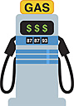

verb adjective noun