Me llamo___________________________________

**El vocabulario para Unidad _1_. _1_**

**Los cognados – (look like English AND have the same meaning)**

1. _____________________ 6. _____________________ 11. _____________________

2. _____________________ 7. _____________________ 12. _____________________

3. _____________________ 8. _____________________ 13. _____________________

4. _____________________ 9. _____________________

5. _____________________ 10. ____________________

**Otras frases**

15. flight attendant 15.______________________________

16. to go on vacation 16. ______________________________

17. to call someone 17. ______________________________

18. boarding pass 18. ______________________________

19. bathing suit 19. _______________________________

20. to go through security 20. _______________________________

21. Can you please tell me where…? 21. _______________________________

22. to take (a taxi) 22. _______________________________

23. trip 23. _______________________________

24. airplane 24. _______________________________

**PALABRA:**

____________________

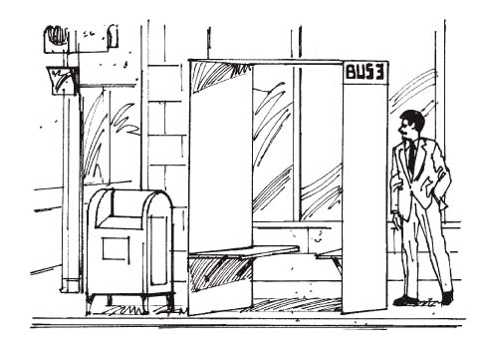

verb adjective noun

**PALABRA:**

____________________

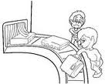

verb adjective noun

**PALABRA:**

____________________

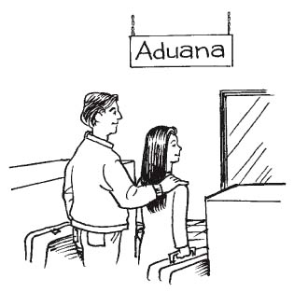

verb adjective noun

**PALABRA:**

____________________

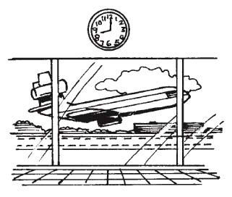

verb adjective noun

**PALABRA:**

____________________

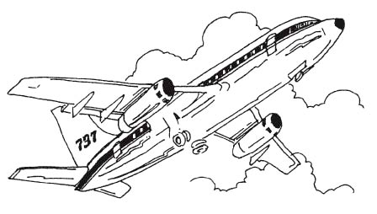

verb adjective noun

**PALABRA:**

____________________

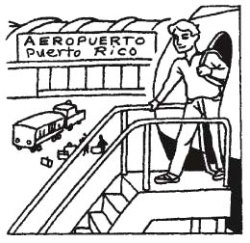

verb adjective noun

**PALABRA:**

____________________

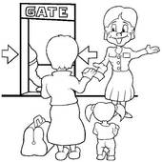

verb adjective noun

**PALABRA:**

____________________

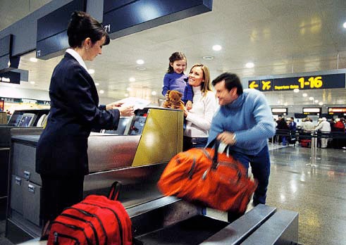

verb adjective noun

**PALABRA:**

____________________

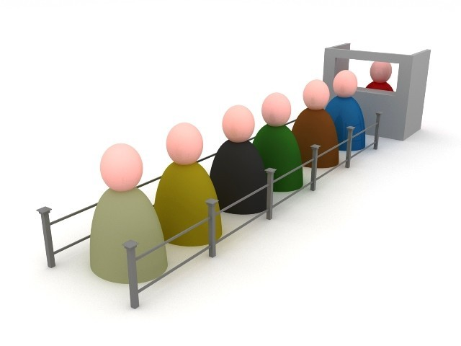

verb adjective noun

**PALABRA:**

____________________

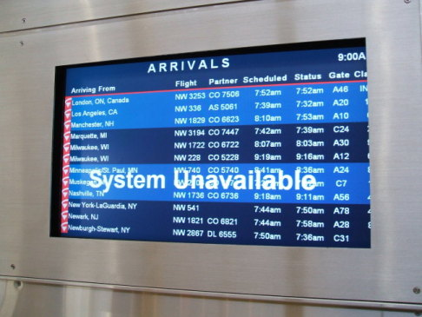

verb adjective noun

**PALABRA:**

____________________

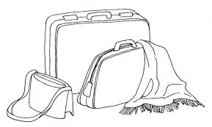

verb adjective noun

**PALABRA:**

____________________

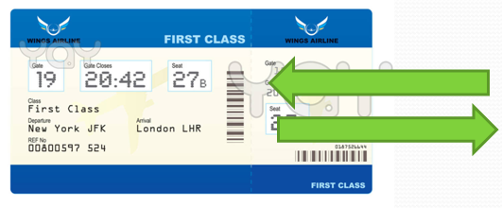

verb adjective noun

**PALABRA:**

____________________



verb adjective noun

**PALABRA:**

____________________

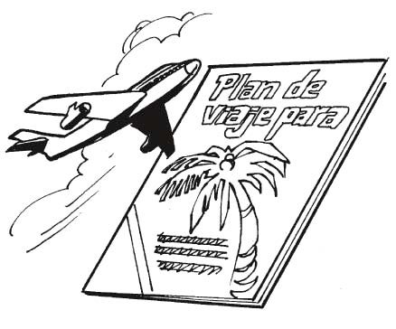

verb adjective noun

**PALABRA:**

____________________



verb adjective noun