Me llamo___________________________________ Tarea __________

**El vocabulario para Unidad _4_. _2_**

**Los cognados – (look like English AND have the same meaning)**

1. _____________________ 7. _____________________ 13. _____________________

2. _____________________ 8. _____________________ 14. _____________________

3. _____________________ 9. _____________________ 15. _____________________

4. _____________________ 10. _____________________ 16. _____________________

5. _____________________ 11. ____________________ 17. ____________________

6. _____________________ 12. ____________________ 18. ____________________

**Usa**  **página 241 en el libro para encontrar el español.**

19. city 19.______________________________

20. How do I get to…? 20. ______________________________

21. to the right 21. ______________________________

22. to the left 22. ______________________________

23. from 23. _______________________________

24. between 24. _______________________________

25. across from 25. _______________________________

26. to, until 26. _______________________________

**Espacio Extra:**

**PALABRA:**

____________________

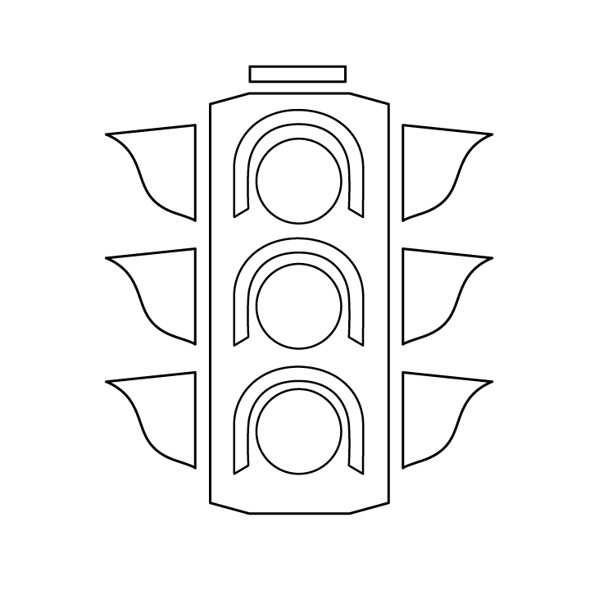

verb adjective noun

**PALABRA:**

____________________

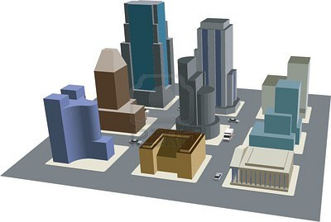

verb adjective noun

**PALABRA:**

____________________

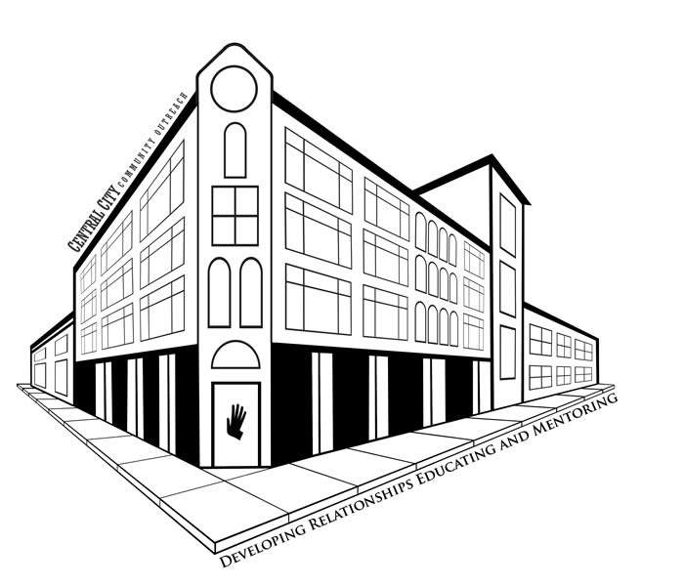

verb adjective noun

**PALABRA:**

____________________

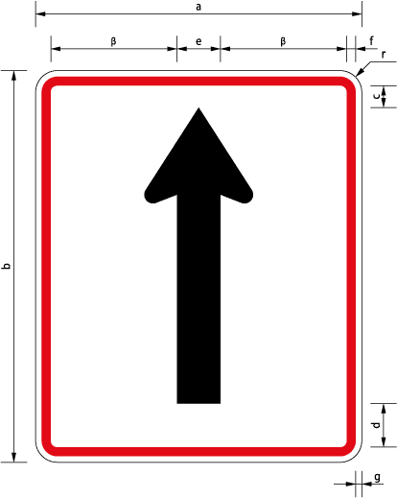

verb adjective noun

**PALABRA:**

____________________



verb adjective noun

**PALABRA:**

____________________

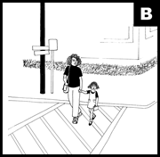

verb adjective noun

**PALABRA:**

____________________



verb adjective noun

**PALABRA:**

____________________

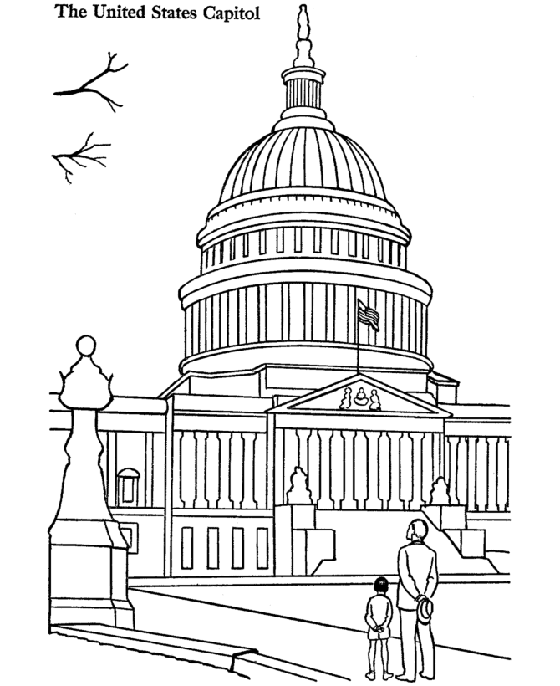

verb adjective noun

**PALABRA:**

____________________

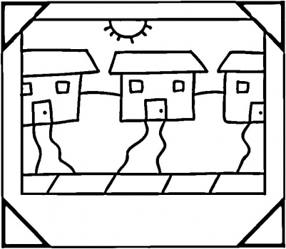

verb adjective noun

**PALABRA:**

____________________

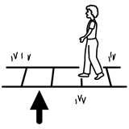

verb adjective noun

**PALABRA:**

____________________

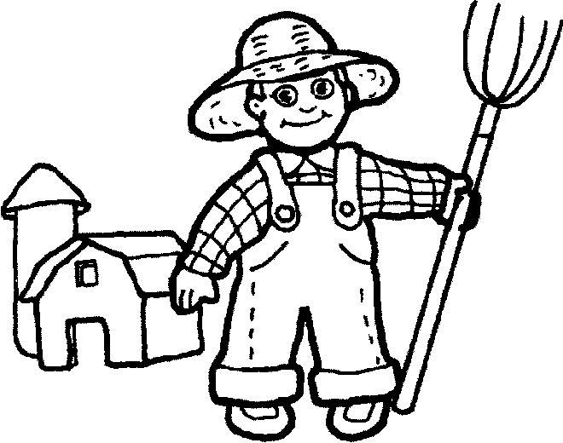

verb adjective noun

**PALABRA:**

____________________

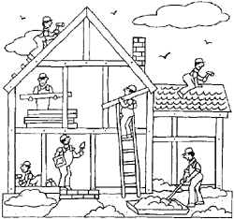

verb adjective noun

**PALABRA:**

____________________



verb adjective noun

**PALABRA:**

____________________

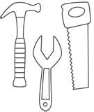

verb adjective noun

**PALABRA:**

____________________



verb adjective noun