Me llamo___________________________________ Tarea __________

**El vocabulario para Unidad _4_. _1_**

**Los cognados – (look like English AND have the same meaning)**

1. _____________________ 6. _____________________ 11. _____________________

2. _____________________ 7. _____________________ 12. _____________________

3. _____________________ 8. _____________________ 13. _____________________

4. _____________________ 9. _____________________ 14. _____________________

5. _____________________ 10. ____________________

**Usa**  **página 217 en el libro para encontrar el español.**

15. young man/ woman 15.______________________________

16. war 16. ______________________________

17. to die 17. ______________________________

18. to return 18. ______________________________

19. beloved 19. _______________________________

20. jealousy 20. _______________________________

21. Once upon a time there was/ were… 21. _______________________________

22. Many centuries ago… 22. _______________________________

23. about 23. _______________________________

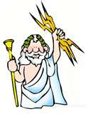

**Espacio Extra:**

**PALABRA:**

____________________



verb adjective noun

**PALABRA:**

____________________



verb adjective noun

**PALABRA:**

____________________



verb adjective noun

**PALABRA:**

____________________

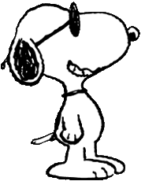

verb adjective noun

**PALABRA:**

____________________



verb adjective noun

**PALABRA:**

____________________



verb adjective noun

**PALABRA:**

____________________



verb adjective noun

**PALABRA:**

____________________



verb adjective noun

**PALABRA:**

____________________



verb adjective noun

**PALABRA:**

____________________



verb adjective noun

**PALABRA:**

____________________



verb adjective noun

**PALABRA:**

____________________



verb adjective noun

**PALABRA:**

____________________

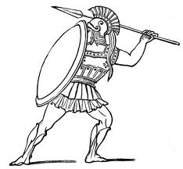

verb adjective noun

**PALABRA:**

____________________

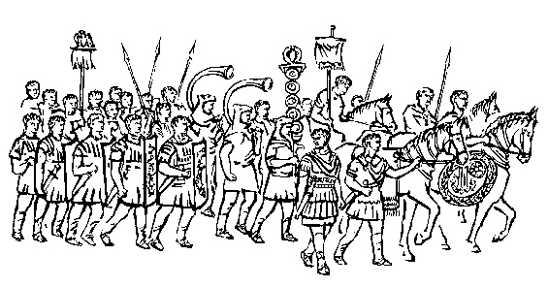

verb adjective noun

verb adjective noun

**PALABRA:**

____________________

verb adjective noun